Marketing Requests: How To
WashU · ICON · Wash Associates · October 2026

What it is
Marketing Requests is the one place to ask marketing for things: uniforms, signs, business cards, banners, event kits, promos, listing fixes, customer texts. You submit a short form, marketing works it in one queue, and you follow the status without texting anyone.
Role | Who | What you do
Requester | General managers and district leads, for their own site(s) | Submit requests, follow them, comment, cancel, keep your crew's size roster current
Marketing | Mitch, Emilee | Work the queue, change status, issue uniforms from hub stock, place vendor orders, run the stockroom and reports
Admin | Mitch | Everything above, plus adding people to the roster, sites, and API keys for the Team Portal

Signing in. Use the Marketing Requests tile in the Team Portal, or go straight to the app and sign in with your work Microsoft account. The first time you sign in you see a page saying you're not on the roster yet; marketing adds you (and your site) and you're in. Everything works on a phone.
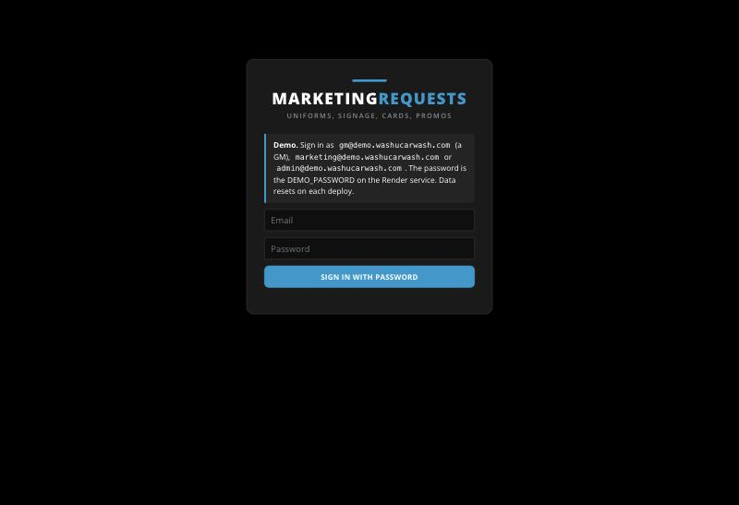
The sign-in page

For general managers: ask, follow, done
A request takes about two minutes on your phone. Marketing sees it the moment you submit, and the status on the request tells you where it stands.
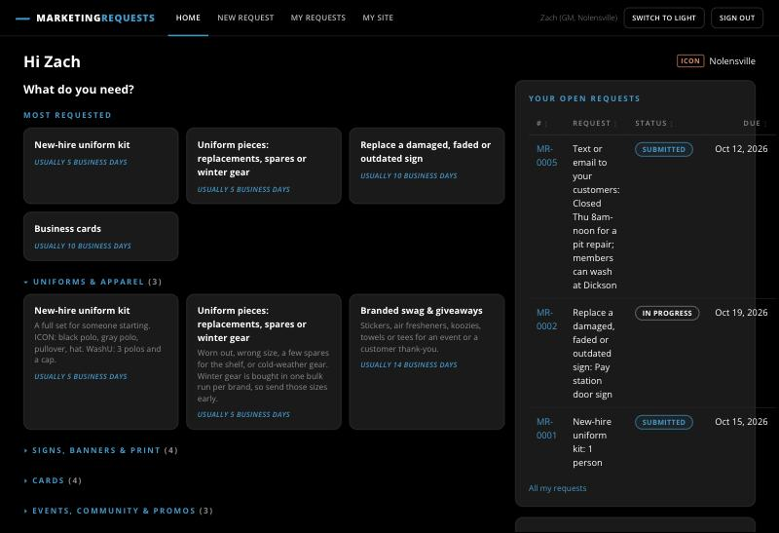
Home: the most-requested types on top, your open requests on the right

1. Pick what you need
Home shows the four most common requests first (new-hire kit, uniform pieces, replace a sign, business cards). Open a group below for the rest: signs and banners, cards, events and community, online and customer messages, or "something else" when nothing fits. Each tile says how long it usually takes, in business days.

2. Fill in the short form
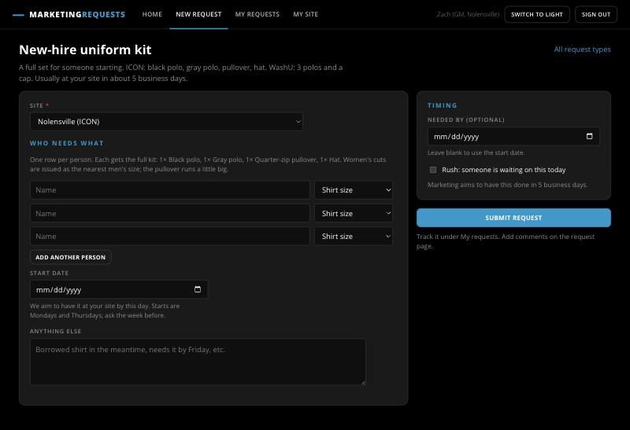
The new-hire kit form: one row per person, a start date, and the Rush box
- Your site is already selected if you run one site; district leads pick the site first.
- Uniform requests are one row per person: name and shirt size. A new-hire kit is the full set (ICON: black polo, gray polo, pullover, hat). For replacement pieces you type how many of each piece; a hat needs no size.
- For signs, a phone photo of the spot saves marketing a site visit.
- Business cards prefill your name and email; add your phone and title.
- Needed by is optional; Rush means someone is waiting on it today.
- Red stars mark required fields. If something is missing, the form keeps what you typed and points you to it.

3. Follow it
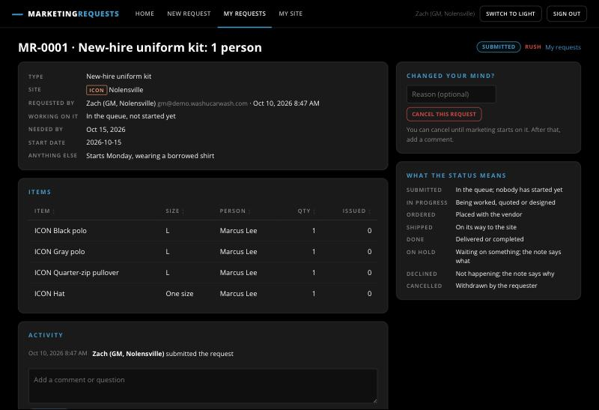
A submitted request: who's on it, the target date, the items, the activity trail, and Cancel this request
After you submit you land on the request. It shows who's working on it, the target date, and everything that happens, in order. Add a comment there instead of texting; marketing and anyone rostered for your site can see it. You can cancel a request yourself until marketing starts on it; after that, leave a comment. My requests lists everything open for your site; All shows the history.

4. Keep your size roster current
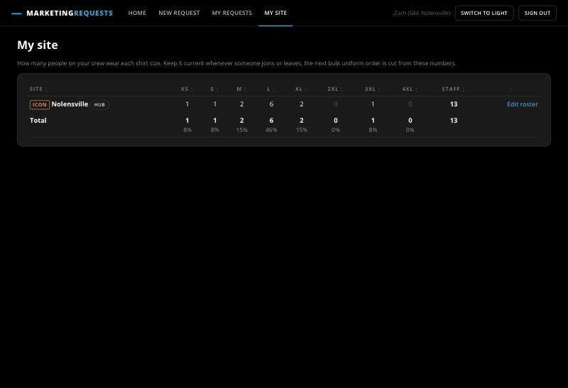
My site: how many people wear each shirt size
My site is a count of your crew by shirt size. Edit it when someone joins or leaves: the next bulk uniform order for your brand is cut from these numbers, so an accurate roster means the right sizes on the shelf when you need them.

For marketing: working the queue
Everything a GM submits lands in one queue, oldest first. Nothing needs approval; you take it, work it, and keep the status honest so the GM never has to ask.
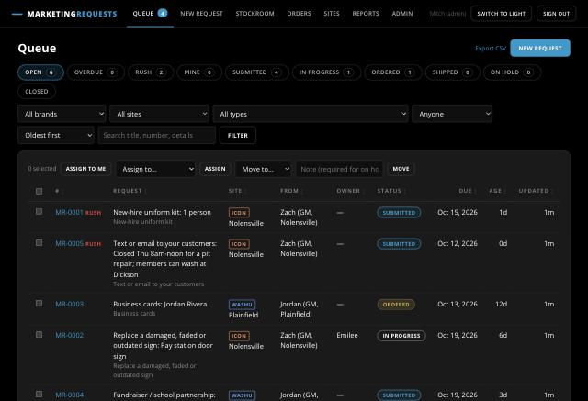
The queue, with Overdue, Rush and Mine chips and the bulk-action bar
- Scan the chips. Open shows everything in flight. Overdue (past the needed-by date or our own turnaround), Rush (the GM said someone is waiting today) and Mine narrow it in one click. Filters below cover brand, site, type and owner; the search box reads titles, numbers and the form answers.
- Take it. On a request, Take it assigns it to you and moves it to In progress in one click. For several at once, tick rows and use Assign to me or Move to in the bar above the table.
- Update the status with a note. Move to Ordered, Shipped or Done as it happens. On hold and Declined require a note to the requester; it goes in the activity trail and to the GM.
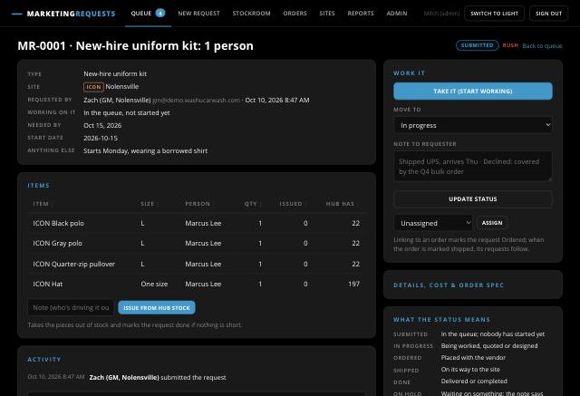
A request from the marketing side: items with hub stock on hand, Issue from hub stock, and the Work it panel
- Uniforms: Issue from hub stock. On a uniform request the Items table shows what the hub has for each size. Issue from hub stock takes the pieces out of stock, logs the movement against the request and the site, and marks the request Done if nothing was short. If a size is short it says so and leaves the rest open.
- Print and signage: link a vendor order. Log the order under Orders (vendor, what, cost, tracking), then link the request to it from the request page; it moves to Ordered. When you mark the order shipped, every request on it moves to Shipped.
- Details, cost and order spec. The collapsed panel holds the vendor, cost estimate and actual, and the order spec (product, colour, ship-to, artwork link). Fill it in as you go; it feeds reports now and the ordering agent later.
- Internal notes. Tick Internal on a comment and only marketing sees it.

The stockroom
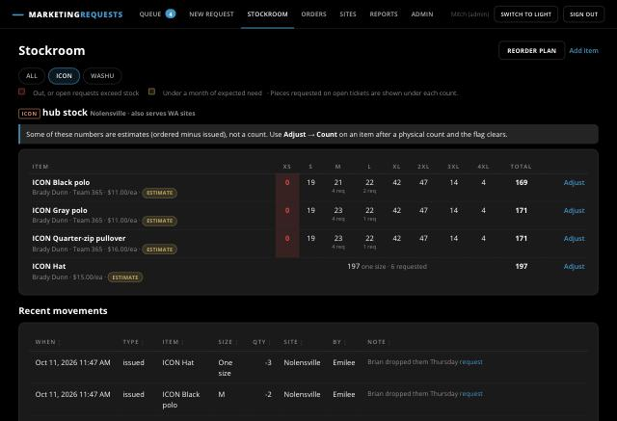
ICON hub stock by size, with requested pieces under each count
The Stockroom is the hub shelf (Nolensville for ICON and WA, Plainfield for WashU) by item and size. A red cell is out, or has more pieces requested than on hand; amber is under a month of expected need. The small number under a count is how many pieces are owed on open requests. Adjust on a row opens Receive (a delivery arrived), Issue (pieces went out without a request) and Count (replace the numbers with what is on the shelf; this clears the "estimate" flag). Issuing more than is on hand is refused, so the movement log always matches the shelf.
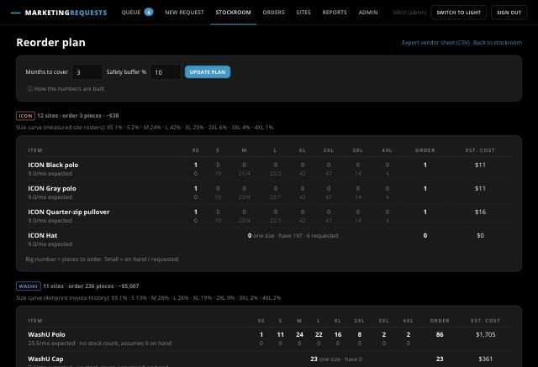
The reorder plan: pieces to order per size, with on hand and requested underneath
Reorder plan turns stock, open requests and the size curve into what to order per item and size for the next quarter (months to cover and the safety buffer are adjustable). The ICON curve comes from the site rosters; WashU uses the 4imprint invoice history until IL rosters exist. Export vendor sheet gives a CSV to send to Brady or 4imprint.

Orders and reports
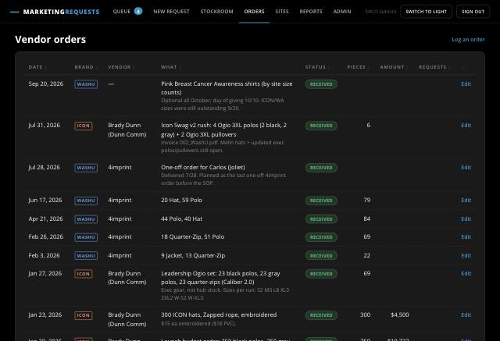
Vendor orders, newest first, with the requests riding on each
Orders is the history of every vendor purchase, with the requests riding on each one. Logging an order does not change stock; Receive on the Stockroom does when the boxes land.
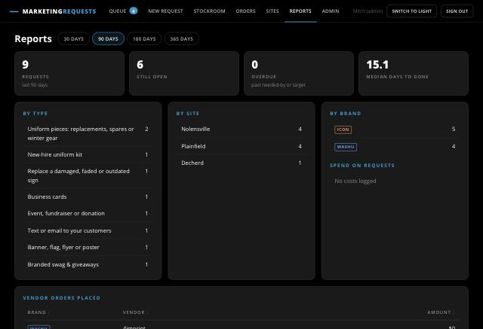
Reports: volume, open and overdue counts, median days to done, by type, site and brand
Reports show volume by type, site and brand, how many are open and overdue, the median days from submit to done, and spend by vendor. Export CSV on the queue gives the full ticket list.

For admins: people, sites and the Team Portal
Admin is Marketing plus three things: who may submit, which sites exist, and the keys other systems use.
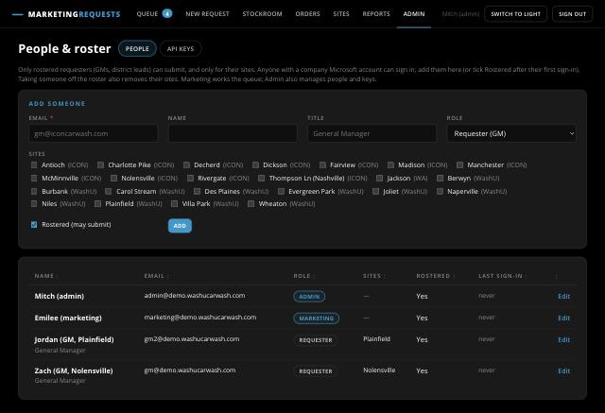
Admin → People: add a GM, tick their site, tick Rostered
People. Anyone with a company Microsoft account can sign in, but only rostered people can submit, and only for the sites ticked here. Add a GM with their email and site before their first day, or tick Rostered after they've signed in once. Marketing and Admin roles see every site. Taking someone off the roster also clears their sites, so they stop seeing that site's requests.
Sites. The Sites page lists every location with its size roster, hires in the last 12 months and notes. Admins can add a site, change its brand, mark it as a hub (it holds uniform stock) or set it inactive.
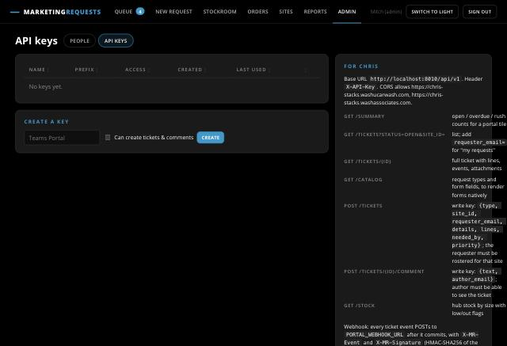
Admin → API keys: create a key for the Team Portal; the key is shown once
API keys. Chris's Team Portal and the MCP server talk to the app with a key sent as the X-API-Key header. Read keys can list and read; tick "Can create tickets & comments" for a key that can also submit on a rostered GM's behalf, change status or log orders as a marketing user. The key is shown once, so copy it then. Revoke a key here if it leaks. The panel on the right lists the endpoints and the webhook that posts every ticket event to the portal.

Status glossary and FAQ
Status | Meaning | Who sets it
Submitted | In the queue; nobody has started yet | Automatic
In progress | Being worked, quoted or designed | Marketing (Take it)
Ordered | Placed with the vendor | Marketing, or linking to a vendor order
Shipped | On its way to the site | Marketing, or the vendor order being marked shipped
Done | Delivered or completed | Marketing, or Issue from hub stock
On hold | Waiting on something; the note says what | Marketing, with a note
Declined | Not happening; the note says why | Marketing, with a note
Cancelled | Withdrawn by the requester | The GM, while still Submitted or On hold

How long will it take? Each request type shows its usual turnaround in business days on the tile and the form. Printed pieces add the vendor's lead time; winter uniform gear waits for the brand's bulk order.
I need it faster. Tick Rush when someone is waiting today, and put the date in Needed by. Rush requests sort to the top of the queue.
Can I change a request after submitting? Add a comment on it; marketing sees it immediately. You can cancel it yourself until marketing starts on it.
Why can't I submit? You're not on the roster yet, or your site isn't ticked. Ask marketing (mhoffman@washucarwash.com).
Where do uniforms come from? The hub (Nolensville for ICON and Wash Associates sites, Plainfield for WashU). Marketing issues from the shelf or adds your sizes to the next vendor order.
Who sees my request? You, anyone rostered for your site, and marketing. Marketing's internal notes are not shown to requesters.

